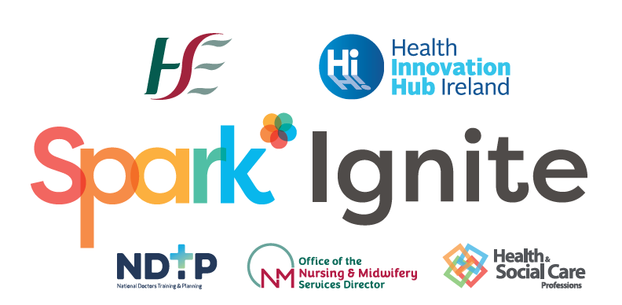

Overview
Health Innovation Hub Ireland (HIHI), National Doctors Training and Planning (NDTP), the Office of Nursing and Midwifery Service Development (ONMSD), and the National Health and Social Care Professions Office (HSCP) are seeking idea proposals from all HSE staff. The ideas should be a solution to a problem, challenge or unmet need within the healthcare system.
All ideas are welcome and the competition is open to all departments and disciplines within the HSE.
About
HSE-HIHI Spark Ignite is the only staff-facing, bottom up, innovation competition available to the 115,000+ HSE employees. Its mission is to enable HSE staff to validate unmet needs in healthcare, determine if a market exists for their proposed solution, product, or service to meet that need, and to support the further development of those ideas.
Applications are simple and straight forward submitted via an online portal to HIHI. Successful applicants will benefit from a bespoke healthcare focused innovation workshop delivered by experts to hone their idea and proceed to pitch for two €3000 first prizes and three €1000 runner-up prizes. The pitches will take place as an evening event in the style of “Dragons’ Den” before a panel of experienced judges.
This initiative provides funding for good ideas as well as the training and mentorship required to move those ideas towards reality.
For more information visit www.hih.ie, see associated promotional material, and social media #HSEHIHISparkIgnite.
National Event
HSE-HIHI Spark Ignite is a national initiative divided into three regional areas (Dublin, Cork, and Galway) with an opportunity to pitch for funding at each of the HIHI locations. The winners in each regional final will progress to a National Final.
Innovation Workshops
In each region, 12 applicants will receive an opportunity to participate on an innovation workshop to learn the process and help develop their idea. The innovation workshop will be delivered by experts two evenings a week over four weeks online. This will prepare the participants to pitch their idea before a panel of expert judges in a “Dragons’ Den” style finale.
Prizes
The winners of the competition will receive funding and on-going support and mentorship from HIHI to develop their ideas.
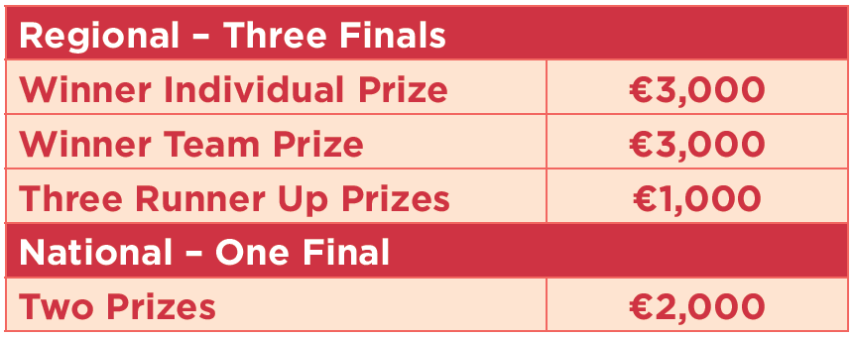

Information
Please read the application form carefully before completing it.
Advice and assistance is available from HIHI.
For general enquiries, please contact HIHI at info@hih.ie or on 021-4205560 or your nearest HIHI office:
Ms Jane O’Flynn jane.oflynn@cit.ie 021 432 6758 (Cork)
Dr Tanya Mulcahy t.mulcahy@ucc.ie 021 420 5556 (Cork)
Ms Eimear Galvin galvinei@tcd.ie 01 896 25 29 (Dublin)
Dr Steven Griffin steven.griffin@nuigalway.ie 091 492072 (Galway)
Submission
Applications should be submitted via this (link)
You will receive an automated email response acknowledging receipt of application. If you do not receive this acknowledgement, please contact info@hih.ie.
Closing Date
5pm Friday, March 25th, 2020.
Confidentially
The HIHI team will treat all applications confidentially.
HSE-HIHI Spark Ignite Application Form

Name

Job Title/Role
Organisation | e.g., name of the building where you work
Area | e.g., acute hospital, primary care, community care, other (please state)

Contact Email

Telephone Number
Closest Health Innovation Hub | i.e., Cork, Galway, or Dublin

HIHI Contact Person

Title:
- What is the title of your idea?

Problem: (200 Words Max.)
- What is the problem, challenge or unmet need in healthcare that your idea will address?
- What is the clinical impact of the problem i.e., how many people are affected by it?
- What is the commercial impact of the problem i.e., how much does it cost to address/treat annually?

Current Solutions: (200 Words Max.)
- What are the current solutions available to address the problem?
- What is being done locally, nationally, and internationally?
- Why, in your opinion, do these solutions fail to address the problem?

Stakeholders: (200 Words Max.)
- What groups do the problem affect? E.g., patients, clinical teams, administrative teams, carers, managers, patient advocacy groups, government, etc.
- Of the groups that you have identified, how does the problem affect them specifically? i.e., the problem may affect a patient differently to how it would affect other groups.

Your Solution: (200 Words Max.)
- What is your solution?
- How is it better than the current solutions listed above i.e., does it fill a gap the other solutions are missing?
- How does it benefit the different stakeholder groups you identified i.e., will it address the problems that the stakeholders are facing?

HIHI Spark Ignite – Term & Conditions
By submitting a proposal to the HSE-Health Innovation Hub Ireland Spark Ignite 2021 (the “HSE-HIHI Spark Ignite”) (a “Proposal”), you (the “Participant”) agree to be bound by these terms and conditions. Promotional materials relating to the HSE-HIHI Spark Ignite, including all information on how to enter the HSE-HIHI Spark Ignite and related application forms, also form part of these terms and conditions. In the event of any conflict between any terms referred to in any such promotional materials and these terms and conditions, these terms and conditions take precedence.
- The promoter of the HSE-HIHI Spark Ignite is University College Cork – National University of Ireland, Cork (“UCC”).
- The HSE-HIHI Spark Ignite is open to all HSE staff and voluntary hospital staff with an idea to address a challenge, problem, or unmet need in healthcare.
- Participants who are natural persons must be at least 18 years old.
- Any illegible, incomplete or fraudulent proposals will be rejected.
- Proposals will be evaluated in accordance with the selection criteria outlined in the HSE-HIHI Spark Ignite and related promotional materials. The successful Proposals will be selected by an evaluation panel comprising experts selected by Health Innovation Hub Ireland. The decision of the panel will be final and no correspondence will be entered into.
- Participants whose proposals are selected for participation in an innovation mini-accelerator will be required to participate in eight 1-2 hour workshops in person or via web link. The workshops will be spread over four weeks i.e., two evenings a week. Dates will be confirmed when the call is closed. Failure to enter into such agreement will result in the Proposal disqualification.
- Any copyright and other intellectual property rights (“IP”) in any Proposal shall, as between the Participant and UCC, remain vested in the Participant.
- Furthermore, each Participant represents and warrants that it has obtained all rights, licences, and permissions necessary, in writing, from any person who may have helped create and/or be featured in its Proposal and that its Proposal fully complies with these terms and conditions and: (a) is the Participant’s original work and does not include the work of a third party, or if it does include such work that the Participant has obtained all rights, licences, and permissions necessary, in writing; (b) does not include trademarks, logos, or copyright protected material which belongs to third parties without permission; (c) is not subject to any third party agreements and UCC will not be required to pay or incur any sums to any person or entity as a result of its use (as set out in these terms and conditions); (d) does not defame, misrepresent, or contain disparaging remarks or any other content which could adversely affect the name, reputation or goodwill of UCC, the Health Service Executive or any other party collaborating in the Health Innovation Hub Ireland Initiative; and (e) does not violate any applicable local state, provincial, national or international law or include any content that would encourage or provide instructions for a criminal offence. UCC reserves the right to disqualify any Proposal if it suspects any breach of these terms and conditions or if it receives any complaint from a third party relating to such Proposal.
- By submitting a Proposal, the Participant agrees to have its name and entry featured in publicity materials relating to HSE-HIHI Spark Ignite without further reference, payment or other compensation. This includes making their name and non-confidential details in relation to their Proposal available to the Health Service Executive, Enterprise Ireland and any other party collaborating in the Health Innovation Hub Ireland initiative.
- UCC reserves the right to modify, cancel, terminate or suspend the HSE-HIHI Spark Ignite in whole or in part, at its sole discretion, if it believes the HSE-HIHI Spark Ignite is not capable of being conducted as specified within these terms and conditions or in the event of any cause that is beyond the reasonable control of UCC that could corrupt or affect the administration, security, impartiality or normal course of the HSE-HIHI Spark Ignite. UCC shall not be responsible for any condition, circumstances, losses, failures or delays caused by events beyond its control.
- Any Participant who submits or attempts to submit a Proposal in a manner, which in UCC’s reasonable determination is contrary to these terms and conditions or by its nature is unjust to other participant (including without limitation tampering with the operation of HSE-HIHI Spark Ignite, canvassing or any other unfair practices) may be rejected from HSE-HIHI Spark Ignite at UCC’s sole discretion.
- These terms and conditions and any non-contractual obligations arising out of or in connection with them shall be governed and construed by Irish law. The courts of Ireland shall have exclusive jurisdiction to hear any dispute or claim arising out of or in connection with HIHI Spark Ignite, these terms and conditions or any related non-contractual obligations and each Participant submits to the exclusive jurisdiction for that purpose.

