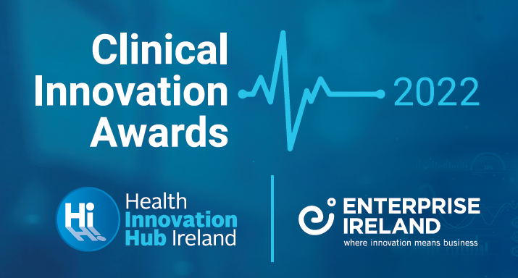
Enterprise Ireland in partnership with Health Innovation Hub Ireland recognise the importance of clinical innovation to address current unmet clinical needs for patients within the healthcare system and wider medtech sector. The Clinical Innovation Awards are designed to support clinicians and other healthcare professionals in Ireland to explore the commercial feasibility of their innovative ideas and the potential to transform the way medical care is delivered in Ireland and abroad. The Award welcomes innovative technologies at all stages of development from concept, early stage research through to more advanced projects.

WHAT IS THE CLINICAL INNOVATION AWARD?
Three winners of the award will receive a €15,000 Enterprise Ireland Commercialisation Feasibility Fund to investigate the commercial feasibility of their innovative idea in Ireland and international markets. The winners will be announced at Enterprise Ireland’s Big Ideas event in November 2022.
Winners will have an opportunity to engage with the Clinical Entrepreneur Programme in the NHS.

The closing date for applicationS is 29 SEPTEMBER 2022

PROJECT TITLE

APPLICANT DETAILS
Name:
Department:
Healthcare Organisation:
Associated Academic Institution:
HIHI Contact:
Email:
Mobile number:

Please complete sections 1-4. The Lead Applicant and a member of the associated academic institution’s Technology Transfer Office (TTO) MUST sign the application.

- Briefly describe the innovation/technology solution (Maximum 1 page)
- Provide a description of your innovation/technology solution and the clinical need it addresses
- Describe the technology ready level (TRL) of your solution
- Outline the development pathway for your innovation/technology solution?

- Outline the advantages of your innovation/technology solution over existing research / current methods? (Maximum 1 page)
- Identify existing competitor solutions
- Detail the strengths and weaknesses of existing solutions
- Describe the advantages of your proposed innovation/technology solution

- Outline the commercial opportunity for this innovation/technology solution and who will benefit from it? (Maximum 1 page)
- What is the clinical problem that needs to be solved?
- What is the incidence and scale of this problem in Europe, USA and worldwide?
- Who are the customers/end users of the proposed innovation/technology solution?
- Outline the novelty of your innovation based on patent and literature searches

- How do you intend to use the Commercialisation Feasibility award? (Maximum 1/2 page)
- Identify the activities/tasks, listed in the INFORMATION NOTES that are relevant to scoping the commercial case for your innovation/technology solution and why?

Applicant Signature: | Date:
TTO Signature: | Date:

For more information, please contact:
Galway: Steven Griffin Email: steven.griffin@nuigalway.ie
Dublin: Sinéad O’Connor Email: OCONNS71@tcd.ie
Cork: Michael Twomey Email: michael.twomey@ucc.ie

INFORMATION NOTES
Who is Eligible?
- Clinicians in public hospitals, third level institutions and non-profit research organisations
- All healthcare professionals; radiologists, clinical psychologists, nurses, occupational therapists, etc.
- Applicants must be employed and have ongoing clinical commitments in the Irish health service
- Applicants must identify the associated academic institution for their hospital or health centre

Purpose of the award
The award will enable the applicant to engage relevant external experts/consultants to scope the commercial case for their proposed innovation/technology solution. The award can also fund a small demonstration model or early prototype, up to the maximum value of €5,000.
Commercial consultant activities include:
- Market analysis to identify the commercial opportunity for the innovation or technology solution
- Engage with potential customers, end-users, industries and other relevant stakeholders
- Profile emerging and existing competitor landscape for the innovation or technology solution
- Investigate the patent landscape and plan IP strategy
- Understand the regulatory issues or other barriers/hurdles to commercialisation

Submission Process

Applicants must identify the Technical Transfer Officer (TTO) in their associated academic institution and notify them of their application prior to submission. Relevant TTOs can be contacted via the research office in the associated academic research institution.
- An up-to-date CV must be included with the application submission
- Completed and signed applications should be submitted via this portal (link)
- To receive a confirmation email of your submission please follow the instructions at the Submission Confirmation section of the portal

Assessment Criteria and Evaluation Process
Applications will be evaluated by Enterprise Ireland using the following criteria:
- The size of the commercial opportunity
- Advantages of the proposed solution over current solutions
- Technical innovation in terms of innovation, novelty and feasibility
- Benefit to the project of a commercial feasibility assessment
- See the webpage and FAQ for more information

The closing date for applicationS is 29 SETPEMBER 2022

