COMMERCIALISATION FUND PROGRAMME 2022

COMMERCIAL CASE FEASIBILITY SUPPORT APPLICATION FORM

Applicant Details
Name: | CF Applicant | Gender: | Female
Institution: | Test University | Department: | test

Landline Number: | 1234 | Mobile Number: | 1234

Project Details
Address:
Address line 1, address line 2, post code, Ireland
Email:
applicantcf@xxx.com
Date Created:

Reference No:
CF-2021-1782-Y
01/07/2021

Project Title: Status:
Technology area most relevant to your proposal:
Project Duration:
Advisors

Sample -Application to request Support to scope the commercial case for my Innovation Draft
Lifesciences or Information Communication Technology or Manufacturing, Engineering & Food

Three months

Technology Transfer Office Case Manager or equivalent: | This will depend on the TTO you have linked in with
EI Commercialisation Specialist: | Claire Walsh

Progenitor Projects

Progenitor Project(s) / Grant Award(s) Information

List any previous projects or grant awards

Outline the problem/challenge/unmet need that your innovation/solution proposes to address and who you consider the customers will be. Describe the innovation/solution including relevant background research and any market research you have conducted to date:
Project Description

maximum 500 words Describe the problem/challenge/unmet need you consider your innovation solution can solve in the market. Provide an overview of the innovation/solution and how you consider it will solve the problem/challenge/unmet need in the market. Provide an overview on any information gathered to date to support the need for your innovation/solution. Outline who you consider the customers will be for your innovation/solution.
Schematic Upload:
Explain why you consider your innovation/solution is unique and has advantages over existing research/competitors that you are aware of:

Attach any relevant files or images

Name of attached files - Test_Canvas_Sample_CFF.pdf169.8 KB - 01/07/2021 12:21 Total Files: 1

maximum 500 words Describe/Outline what you consider are the unique features/attributes of your innovation/solution.
Outline why you think your innovation/solution is different from existing solutions being used to solve the problem/challenge/unmet need.
Outline why you need Feasibility support, include the commercial questions/unknowns that you need external help with: (Applicants should use a ‘Value Proposition’, ‘Business Model Canvas’, ‘Lean Canvas’ or equivalent to determine the critical project tasks. This analysis should be carried out in collaboration with your TTO/Equivalent and your EI Commercialisation Specialist)
maximum 500 words Describe support by your TTO Case Manager/equivalent and the Enterprise Ireland Commercialisation Specialist having used tools such as Business Model, Lean Canvas and the Value proposition canvas what tasks and expertise are needed to scope the case for your innovation/solution.
Briefly describe your interaction with the TTO or equivalent office regarding this project and others, particularly if they have led to commercial outcomes (i.e. licences, options, spinouts etc.)
maximum 500 words Describe any relevant previous engagements with the TTO and engagements to date on this project.

Project Tasks

Project Tasks List

Task Description: (Examples below for reference)
Duration (weeks):

Identification of Key Stakeholders types (commercial, technical, clinical) and perform Customer 6
Discovery
Determine size of the market and relevant market segment in Key geographies, trends, divers 4
Identify the Major Players in the market, their competing technologies, business models and pricing
Get early regulatory guidance re the likely classification and regulatory requirements/pathway in 2
key geographies

Project Costs

Project Costs Summary Table
Consultant Costs
Number of Days: |  | Daily Rate: | Total:
 | 14 | €850.00 | €11,900.00
 | Justification: | Market and Commercial analysis
 | 3 | €900.00 | €2,700.00
 | Justification: | Regulatory consultant
 |  | Total: | €14,600.00
Travel Costs
 |  | Domestic / Overseas: | Total:
 |  | Total: | €0.00
Prototyping Costs
Number of  Days: | Daily Rate: | Total Labour Cost: Materials: | Total:
 | Total: | €0.00 €0.00 | €0.00
Other Costs
 |  |  | Total:
 |  | Total: | €0.00
 |  | GRAND TOTAL: | €14,600.00

Applicant CV

Applicant's CV:

File NameSizeDate

Standard_CV_Template_PDF.pdf22 KB - 01/07/2021 12:41 Total Files: 1

Privacy Statement

Privacy Statement Agreement:
Enterprise Ireland is committed to its transparency obligations under the General Data Protection Regulation (GDPR). Our data protection notice for personal data that is supplied to us by our clients is available here. This notice contains important information about how we process personal data that is supplied to us by clients. We request that you read the notice carefully and that you ensure that it is made available to any data subjects (e.g. researchers) whose personal d ata you provide to us.

By ticking I agree, you confirm that: (a) you have complied with your own data protection obligations in respect of the personal data that you supply to us and that you are entitled to disclose such personal data to us; and (b) you will ensure that a copy of our data protection notice (available here) is sent to data subjects (e.g. researchers) whose personal data you provide to us.

I agree

The Commercialisation Fund is co-funded by the European Regional Development Fund (ERDF) under Ireland's European Union Structural and Investment Funds Programme 2014-2020.

Heart Surgery Challenges

AI Robot Assistant
Hardware patents

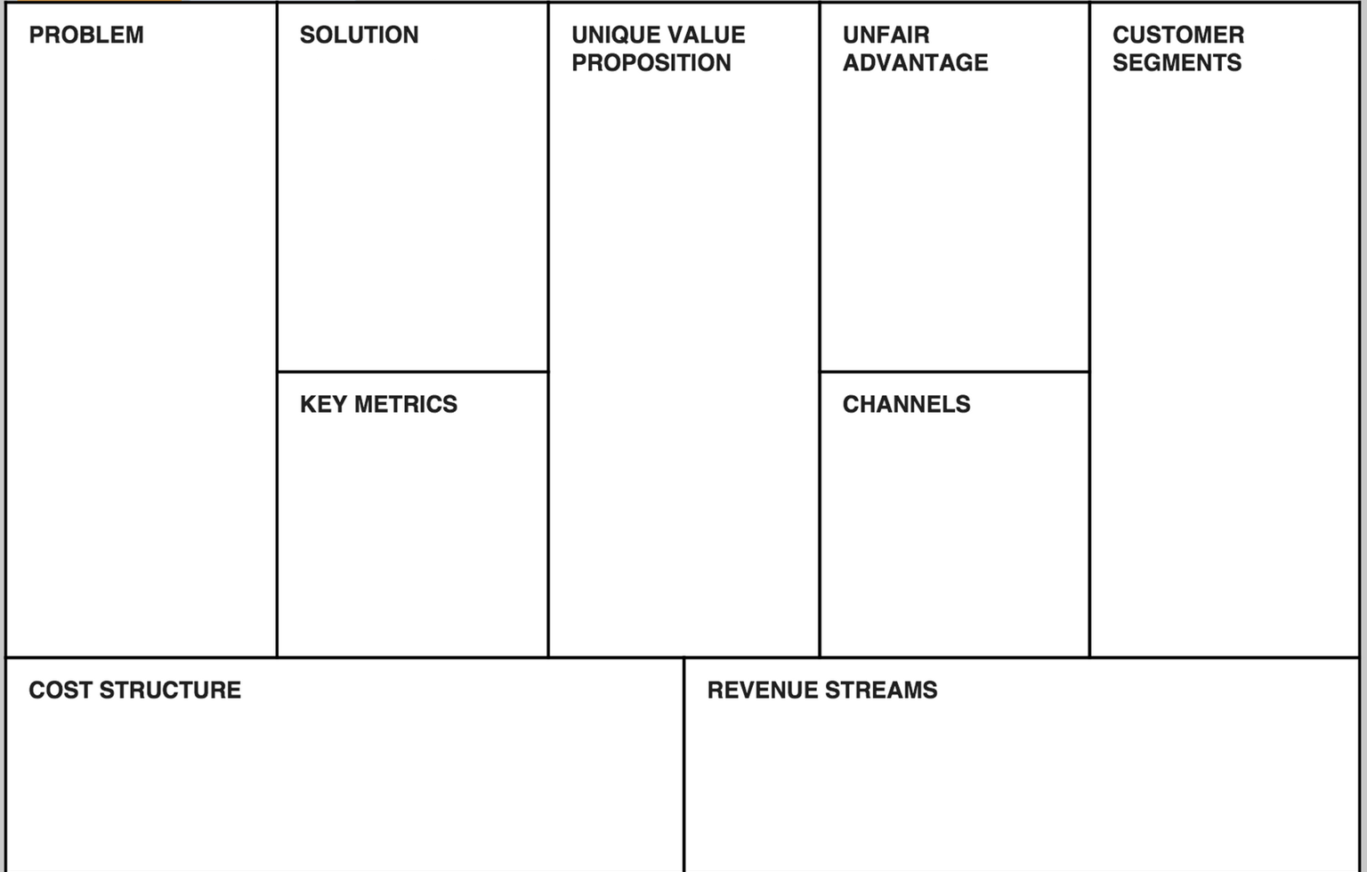
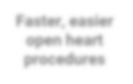
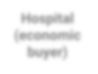
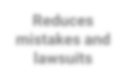
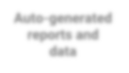
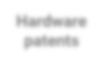
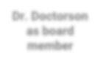
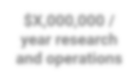
$X,000 / robot manufacturing
Error rate
Proprietary AI
Direct sales
Reduces mistakes and lawsuits
Dr. Doctorson as board member
Hospital (economic buyer)
Auto-generated reports and data
Surgeons (user)
Faster, easier open heart procedures
$X,000,000 /
year research and operations
Month / month retention
Pipeline
Insurance partners
$X,000 /
customer acquisition costs

$X00 / surgery
$X,000 / robot / month rental

Curriculum Vitae: Name Here
Guidance Note-Please do not exceed 2 pages

PERSONAL DETAILS
Present Position: Institution/Affiliation/Company:
Qualifications:
Awards and Honours:
Relevant Professional Memberships/Activities:

CAREER HISTORY
▪
▪
▪

CURRENT RESEARCH INTERESTS
▪
▪
▪

APPLIED RESEARCH ACTIVITY-COMMERCIALISATION OF RESEARCH OUTPUTS
▪
▪

Funded Grants in Past 5 years:
Funding Body Name | Grant Type/Reference number | Year of award | Amount of award

Recent Relevant Publications (Limit to 5):

Recent Relevant Patents (Limit to 5):

