
Application Form
HIHI.AI Call 2025

Health Innovation Hub Ireland (HIHI) is seeking project proposals from companies and organisations developing innovative AI-driven products or services that are either market-ready or in development. Successful innovations should have the potential to make a significant impact on healthcare in Ireland and beyond.

Applications are now open for the HIHI.AI Call 2025, inviting AI-driven innovations that introduce novel solutions to address any healthcare need.

Application Form

Instructions: Please read the associated Briefing Document before completing the application form. Advice and assistance are available from Health Innovation Hub Ireland.

For general enquiries please contact HIHI at info@hihi.ie or your nearest HIHI office:
For more information visit www.hih.ie

Closing Date: Completed applications should be uploaded via this link by 5pm Friday, August the 29th, 2025. You will receive an automated email response acknowledging receipt of application. If you do not receive this acknowledgement, please contact info@hihi.ie

Please provide details of company:
Name

Address

Website

Please provide contact details:
Contact Name

Job Title

Contact Email

Telephone Numbers

Please provide details of product:
Product Name

Stage of Development (tick appropriate box) | Market Ready  (CE marked, where required)
Stage of Development (tick appropriate box) | Pre-commercial  (Product developed and nearly ready for market)
Stage of Development (tick appropriate box) | Product in Development  (Prototype available)

Please provide details of the proposed project:
Project Name

Type of Project  (tick appropriate box)  Note: only products that are market ready (CE marked where required) can be piloted with HIHI. | Pilot Project  provides opportunity to pilot a product in a real-world healthcare setting in Ireland or with the relevant target market.
Clinical/End-user Evaluation Project
provides feedback from key stakeholders, such as clinicians or patients generally through focus groups or one-to-one interviews

Summary
Project Summary: Please provide a summary of your application here. (½ Page Max.)

Proposed Project Duration (Usually Max 3 Months):

Healthcare Need
Please describe the healthcare need that your product addresses, provide data or evidence where relevant. Products will be selected based on their potential to address an unmet clinical need or to effectively improve healthcare through an impactful innovation.
(1 Page Max.)

Applicant Details
Please give a brief overview of your team (½ Page Max)
Key team members and roles, any other relevant information:

Product Description
Please describe your product and how it addresses the identified healthcare need described above. Indicate whether your innovation integrates into current processes or systems within the healthcare systems or is standalone. If you believe your product is impactful and will transform current healthcare practice, please explain (1 Page Max.)

Integration with Healthcare Technology Systems
Please provide details on how your AI system integrates or will integrate with existing healthcare technology systems, for example key interoperability standards such as FHIR - Fast Healthcare Interoperability Resources (1 Page Max.)

Regulatory Approval and Insurance
For Pilot Projects only - Please give details of all regulatory approvals (e.g., CE marking, EU AI Act 2024, and for AI-based medical devices the European Medical Device Regulations (MDR) 2017/745 and In Vitro Diagnostic Device Regulations (IVDR) 2017/746), and insurances in place for the use of this product in Ireland).
The product must have all appropriate regulatory approvals in place before a pilot project can commence. If approval is currently being applied for, please indicate the expected date of this approval. (½ Page Max.)

Intellectual Property
Please provide details of IP (intellectual property) status of your innovation by selecting the relevant answers below.

Has your product IP has been protected? Yes / No / In Progress

Please provide details:
- if Yes, has IP has been protected through: Trademark, Patent, Copyright, Trade Secrets (delete irrelevant terms)

- if In Progress please provide details:

- if No, please explain why not

(½ Page Max.)

Potential Market
Please outline the market potential in Ireland, internationally and list competitive technologies, if known. (½ Page Max.)

Project Plan
Detailed Description of Proposed Project
Consider the objective of the project and what success looks like.
For a pilot project, please outline where and with which users and stakeholders you would like to pilot your product or service and what outcomes would you like to measure at the end of the pilot.
For a clinical evaluation project, please outline what type of clinicians or end-users you would like feedback on your product or service,
(2 Pages Max.)

Resources
Please identify the resources that your team will provide in order to support the project. Please note that supported projects must be delivered at no cost to the Healthcare System. (½ Page Max.)

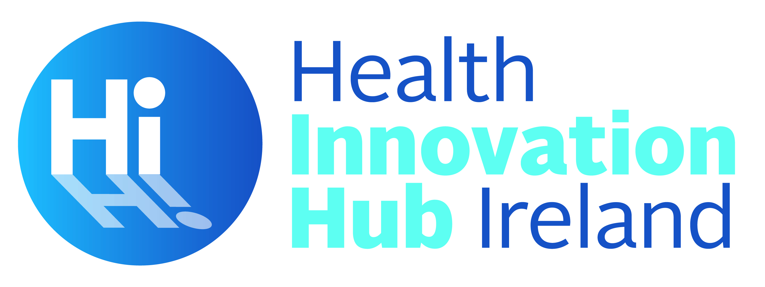
Call for Proposals – Term & Conditions
By submitting a proposal (a “Proposal”) to the Health Innovation Hub Ireland HIHI.AI Call 2025 (the “Call for Proposals”), you (the “Participant”) agree to be bound by these terms and conditions. Promotional materials relating to the Call for Proposals, including all information on how to enter the Call for Proposals and related application forms, also form part of these terms and conditions. In the event of any conflict between any terms referred to in any such promotional materials and these terms and conditions, these terms and conditions take precedence.
- The promoter of the Call for Proposals is University College Cork – National University of Ireland, Cork (“UCC”).
- The Call for Proposals is open to innovators namely; researchers based in Ireland and start-ups and companies registered in Ireland or with a corporate base on the island of Ireland.
- Products proposed for a Pilot Project must be market-ready or at a minimum, at late development phase and have (or will have) all the relevant regulatory approvals in place before the Pilot project commences. Appropriate insurances (Employers Liability, Public Liability and Professional Indemnity) must be in place before commencement of a pilot, where required.
- Products proposed for a Clinical Evaluation Project generally do not need to have all regulatory approvals in place.
- Any illegible, incomplete or fraudulent proposals will be rejected.
- Proposals will be evaluated in accordance with the selection criteria outlined in the Call for Proposals and related promotional materials. The successful Proposals will be selected through a two-stage evaluation process (1) Desk based review of the written application followed by a proposal pitch for shortlisted applicants. Evaluation panels will be comprised of experts selected by Health Innovation Hub Ireland. The decision of the panel will be final, and no correspondence will be entered into.
- Participants whose proposals are selected for participation in a pilot or clinical evaluation project will be required to enter into an agreement with UCC in relation to the conduct of the project on terms to be specified by UCC. Failure to enter into such agreement will result in the Proposal being disqualified.
- Any copyright and other intellectual property rights (“IP”) in any Proposal shall, as between the Participant and UCC, remain vested in the Participant but each Participant grants and agrees to grant to UCC a non-exclusive, fully paid-up licence to use any IP in its Proposal for the purposes of considering and evaluating the Proposal. Each Participant represents and warrants that it has all rights necessary to grant the licence provided for in this paragraph 7 and that all materials forming part of its Proposal, and any use of such materials by or on behalf of UCC in evaluating the Proposal, comply with all applicable laws, rules, and regulations and do not infringe or otherwise violate the intellectual property or other rights of any third party.
- Furthermore, each Participant represents and warrants that it has obtained all rights, licences, and permissions necessary, in writing, from any person who may have helped create and/or be featured in its Proposal and that its Proposal fully complies with these terms and conditions and: (a) is the Participant’s original work and does not include the work of a third party, or if it does include such work that the Participant has obtained all rights, licences, and permissions necessary, in writing; (b) does not include trademarks, logos, or copyright protected material which belongs to third parties without permission; (c) is not subject to any third party agreements and UCC will not be required to pay or incur any sums to any person or entity as a result of its use (as set out in these terms and conditions); (d) does not defame, misrepresent, or contain disparaging remarks or any other content which could adversely affect the name, reputation or goodwill of UCC, the Health Service Executive or any other party collaborating in the Health Innovation Hub Ireland Initiative; and (e) does not violate any applicable local state, provincial, national or international law or include any content that would encourage or provide instructions for a criminal offence. UCC reserves the right to disqualify any Proposal if it suspects any breach of these terms and conditions or if it receives any complaint from a third party relating to such Proposal.
- By submitting a Proposal, the Participant agrees to have its name and entry featured in publicity materials relating to the Call for Proposals without further reference, payment or other compensation. This includes making their name and non-confidential details in relation to their Proposal available to the Health Service Executive, Enterprise Ireland and any other party collaborating in the Health Innovation Hub Ireland initiative.
- UCC reserves the right to modify, cancel, terminate or suspend the Call for Proposals in whole or in part, at its sole discretion, if it believes the Call for Proposals is not capable of being conducted as specified within these terms and conditions or in the event of any cause that is beyond the reasonable control of UCC that could corrupt or affect the administration, security, impartiality or normal course of the Call for Proposals. UCC shall not be responsible for any condition, circumstances, losses, failures or delays caused by events beyond its control.
- UCC shall not be responsible for any damage, loss or injury resulting from any Participant's submission of a Proposal or the selection of the Participant’s proposal, or for technical, hardware or software failures, lost, faulty or unavailable network connections or difficulties of any kind that may limit or prohibit the Participant’s ability to participate in the Call for Proposals. UCC will not be responsible for any lost, damaged, defaced, incomplete, illegible or otherwise unreadable entries. Proof of posting is not proof of receipt by UCC of any Proposal. For the avoidance of doubt, nothing in these terms and conditions shall in any way exclude or limit UCC’s liability (a) under the tort of deceit, (b) for death or personal injury caused by any breach of duty or (c) any other liability to the extent that, under applicable law, it cannot be excluded or limited.
- Any Participant who submits or attempts to submit a Proposal in a manner, which in UCC’s reasonable determination is contrary to these terms and conditions or by its nature is unjust to other participant (including without limitation tampering with the operation of the Call for Proposals, canvassing or any other unfair practices) may be rejected from the Call for Proposals at UCC’s sole discretion.
- These terms and conditions and any non-contractual obligations arising out of or in connection with them shall be governed and construed by Irish law. The courts of Ireland shall have exclusive jurisdiction to hear any dispute or claim arising out of or in connection with Call for Proposals, these terms and conditions or any related non-contractual obligations and each Participant submits to the exclusive jurisdiction for that purpose.

